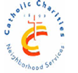CCNS/Sheepshead-Nostrand NORC

3677 Nostrand Avenue, 3A, Brooklyn, NY 11229~718-769-3679

Chrocheting basics 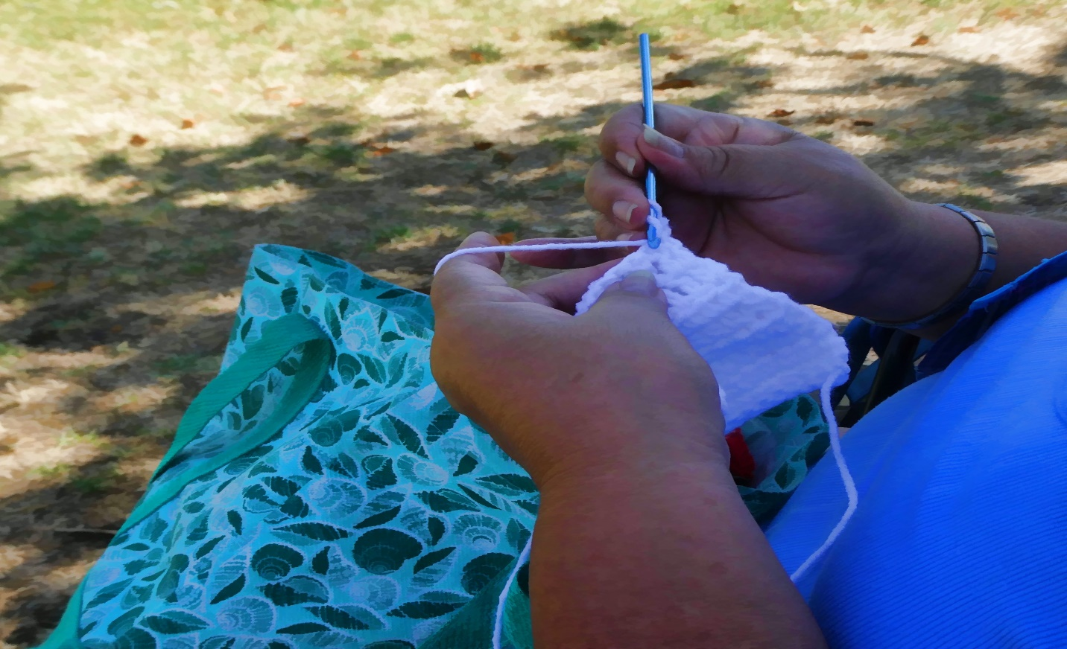

January 17, February 21, March 20 , April 17, May 15, June 19

10:15-11:45

At the Kings Bay Library

**Call: 718-769-3579 for information**

**Funded in partnership with NYC council, NYC department for the Aging, MFTA**

**LIVE LONG & PROSPER AT THE Sheepshead-Nostrand NORC**