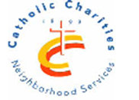CCNS/Sheepshead-Nostrand NORC

3677 Nostrand Avenue, 3A, Brooklyn, NY 11229~718-769-3579

SHEEPSHEAD-NOSTRAND

**WALKING CLUB**

C:\Users\mackerman\AppData\Local\Microsoft\Windows\Temporary Internet Files\Content.IE5\Y99RDLJ9\MC900157213[1].wmf

MEETS EVERY TUESDAY

between 10:00-11:00

**NOSTRAND AVE and AVE V**

**Basketball court**

WALK AT YOUR OWN PACE!!

**LIVE LONG & PROSPER AT THE Sheepshead-Nostrand NORC**

**Funded in partnership with NYC council and NYC Department for the Aging**