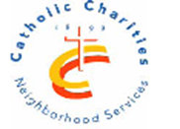
CCNS/ Sheepshead - Nostrand NORC
3677 Nostrand Avenue, Suite 3A, Brooklyn, NY 11229 Tel: 718-769-3579
Virtual Loteria Mexican Bingo
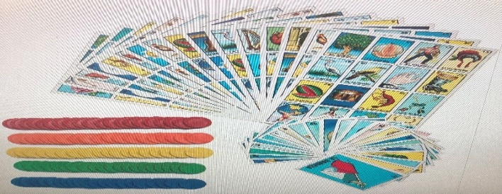
Bilingual Game spanish & English via Phone
with great giweaways
February 26th, March 25th ,
April 29th , May 27th , June 24th
11:00am-12:00pm
For easy set-up instructions
Call:718-769-3579
Funded in partnership with NYC council, NYC department for the Aging, MFTA
LIVE LONG & PROSPER AT THE Sheepshead-Nostrand NORC

