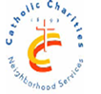CCNS/Sheepshead-Nostrand NORC

3677 Nostrand Avenue, 3A, Brooklyn, NY 11229~718-769-3679

Handmade jewelry & crafts

workshop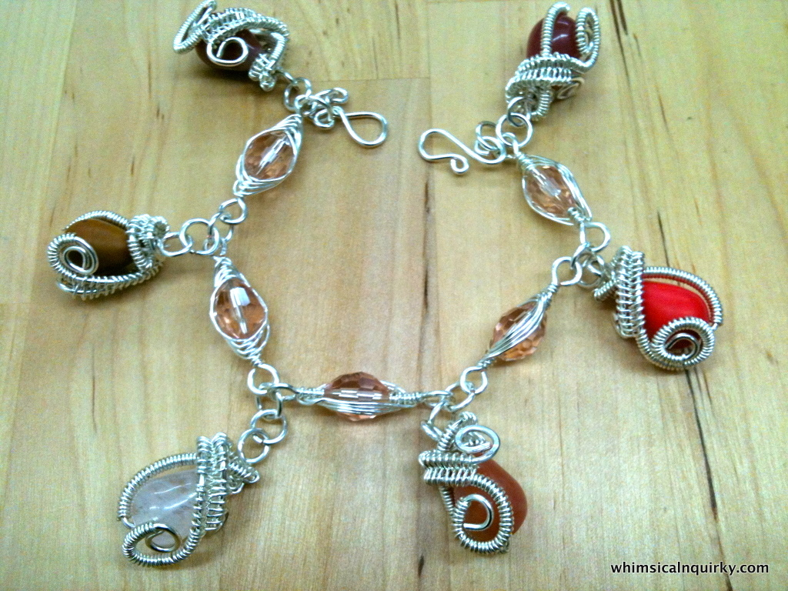

EVERY WEDNESDAY

10:15-11:45

At the Kings Bay Library

**Call: 718-769-3579 for information**

**Funded in partnership with NYC council, NYC department for the Aging, MFTA**

**LIVE LONG & PROSPER AT THE Sheepshead-Nostrand NORC**